Assignment 2

The purpose of this assignment was to create a MIPS Assembly program that subtracts three unsigned integers (x, y, z) entered by the user and displays the result in decimal format. The program begins with a welcome message, prompts the user for input, performs the subtraction, and then displays the result.

The program starts by displaying a welcome message to the user, followed by an input message instructing the user to enter three integers for x, y, and z. This is done using the li, la, and syscall instructions, with appropriate codes (4 for printing strings and 5 for reading integers) in $v0. $a0 stores the string to be displayed by the system call.

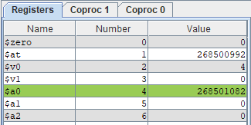

For each of the three inputs (x, y, z), the program displays a prompt using syscall, reads the integer value entered by the user, and stores it in registers $t0, $t1, and $t2 for x, y, and z, respectively.

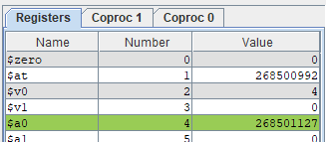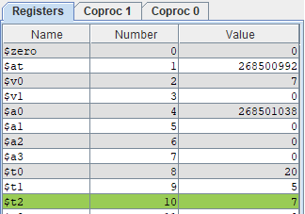

The program then calculates x - y - z using the subu instruction. The subtraction is done step by step. First $t1 is subtracted from $t0, leaving the result stored in $t3. Then a second subtraction, $t2 is taken from the integer stored in $t3, leaving the result stored back in $t3.

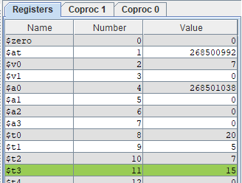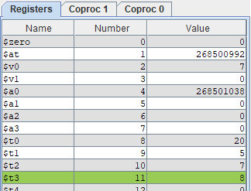

After the calculation, the program displays the result in a message using syscall, and then it prints the result (stored in $t3) as a decimal integer using the appropriate system call code (1 for printing integers). Finally the program exits, using the system call with code 10.

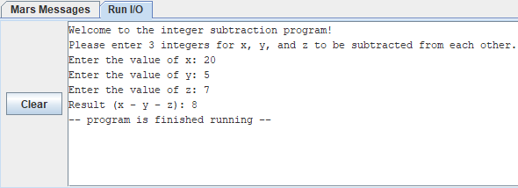

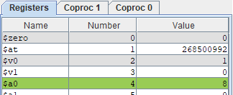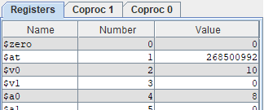

In summary, this assignment centered around the development of a MIPS Assembly program for integer subtraction, encompassing user input and output. The program effectively implemented all the necessary functionalities, including displaying messages, taking user input, performing the subtraction, and displaying the result. Throughout the course of this assignment, I gained a better understanding of MIPS and its system call conventions. Notably, I gained insight into the importance of utilizing the 'subu' instruction instead of 'sub' for this specific task, as 'subu' is specifically designed for unsigned integers. No significant problems or errors were encountered during the implementation, and the program functions as expected.